INDEX

Exercise 1 2
PLAINTEXT 1 5
PLAINTEXT 2 14
PLAINTEXT 3 18
Exercise 2 19
Exercise 3 20
Exercise 4 22

Exercise 1
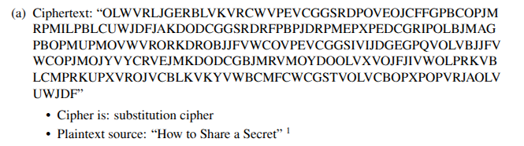

As it corresponds to a substitution cipher, we need to find the mapping between the ciphertext letters and the actual used ones. First, I will perform a frequency analysis to observe which are the most repeated letters:

By counting the letters the following frequency table is obtained:

Letter | Count | % Frequency
V | 30 | 11.45%
O | 25 | 9.54%
P | 24 | 9.16%
J | 21 | 8.02%
R | 18 | 6.87%
C | 18 | 6.87%
G | 14 | 5.34%
L | 13 | 4.96%
B | 13 | 4.96%
D | 13 | 4.96%
M | 12 | 4.58%
W | 10 | 3.82%
F | 9 | 3.44%
E | 8 | 3.05%
K | 8 | 3.05%
I | 5 | 1.91%
S | 4 | 1.53%
U | 4 | 1.53%
X | 4 | 1.53%
Y | 4 | 1.53%
A | 3 | 1.15%
Q | 1 | 0.38%
T | 1 | 0.38%

Now we compare these frequencies with the most frequent letters used in English and we start making guesses. The most frequent letters are E T A O I N.

We start by assigning V -> E and we try O -> T or O -> A
By substituting O -> T we can observe that we can form the word “the” if we set L-> H. As a result, we opt for O -> T.

By performing the substitution L -> H, we are in the following state
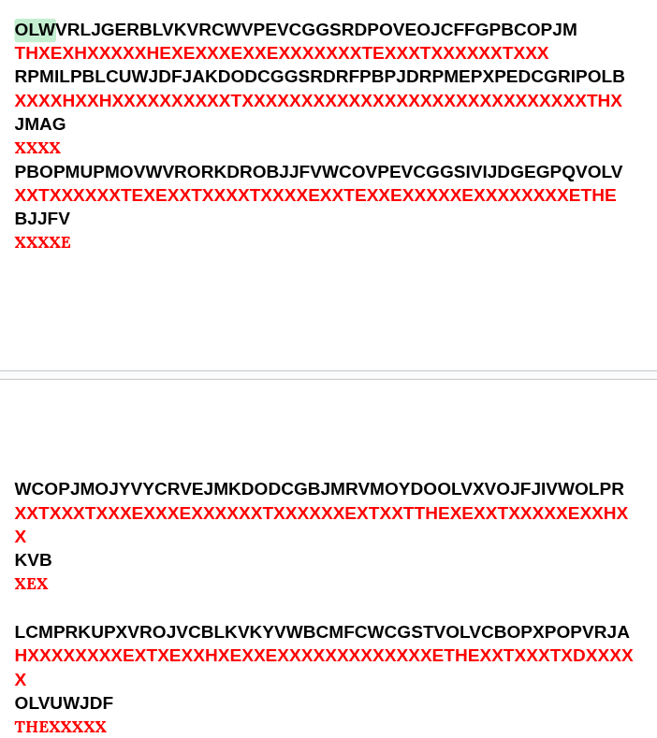
As we can appreciate in the first letters, there seems to be a word being formed. By searching on the original file, where the original message is located, I found that the first word could match “Threshold”. As a result, we try mapping W->R,
R-> S, J ->O G-> L, E-> D we now try substituting.

By performing the previously stated substitutions, we notice that the first two words are threshold schemes.

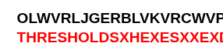
When we look at occurrences of threshold schemes in the original text, we observe that it matches with the following start: “Threshold schemes are ideally…” As a result, we observe that we have found the ciphertext as there is only a single occurrence in the original file with that form. Moreover, by continuing the mapping it can be observed that it exactly matches this sentence.

MAPPINGS:

CIPHER LETTER | ORIGINAL LETTER
V | E
O | T
L | H
W | R
R | S
J | O
G | L
E | D
C | A
W | R
B | C
P | I
K | M
F | P
D | U
U | G
X | V
A | F
The mapping could be continued to develop and be able to translate future messages. However, for this particular example, it is not necessary as we have already found the plaintext. It is:

Precisely, the original text would be:

Plaintext 1
Threshold schemes are ideally suited to applications in which a group of mutually suspicious individuals with conflicting interests must cooperate. Ideally we would like the cooperation to be based on mutual consent, but the veto power this mechanism gives to each member can paralyze the activities of the group.

Removing the full stops and the commas.

This is the technique I used substituting behind the ciphertext. I leave it so that it can be seen how the mapping was applied.
OLWVRLJGERBLVKVRCWVPEVCGGSRDPOVEOJCFFGPBCOPJM
THRESHOLDSCHEMESAREIDEALLYSUITEDTOAPPLICATIONS
RPMILPBLCUWJDFJAKDODCGGSRDRFPBPJDRPMEPXPEDCGRIPOLB
XIXXHICHAXXOXXOXMXTXALLXXSUSPICIOUSXXXXXXXUALSXITHC
JMAG
OXXL
PBOPMUPMOVWVRORKDROBJJFVWCOVPEVCGGSIVIJDGEGPQVOLV
ICTIXXINTERESTSMUSTCOOPEXXTEIDEALLXXEXOULDLXXETHE
BJJFV
COOXE
WCOPJMOJYVYCRVEJMKDODCGBJMRVMOYDOOLVXVOJFJIVWOLPR
XXTXOXTOXXEXXXEDOXMUTUALCOXXEXTXUTTHEVETOPSXXXXEIXHXS
KVB
XEC

LCMPRKUPXVROJVCBLKVKYVWBCMFCWCGSTVOLVCBOPXPOPVRJA
HXXISXGIVESTOEACHMEMBERCAXXAPAXXLXXETHEACTIVITIESXSOF
OLVUWJDF
THEGROUP

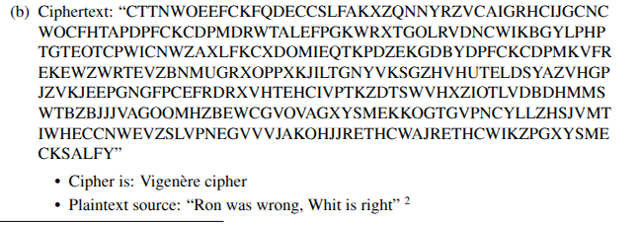

In this case, because it is a vigenère cipher, there is a key involved. We must find the value of that key. First, I looked for repeated sequences in the ciphertext.

There were some sequences that were repeated:
PFCKCDPM -> 8 characters long
XYSME -> 5 characters long
RETHCW -> 6 characters long
EVZ -> 3 characters long

To have a sequence of 8 characters repeated suggests us that the key is at least 8 characters long.

I also used a measurement called the Index of coincidence that measures the probability of choosing two random letters and that they match. The length is more likely to be the one whose IC value approaches more the one from the human alphabet which is 0.0667. I introduced the ciphertext in the following calculator:
Index of coincidence calculator

As a result, it showed that the most likely key length was 8, which matches my previous hypothesis.

Therefore, we focus our study considering a key length of 8 digits.

I now divide the text into groups of 8 digits, each ith digit of a group must have been encoded by using the same letter of the key.

Letter 1 | Letter 2 | Letter 3 | Letter 4 | Letter 5 | Letter 6 | Letter7 | Letter 8
C | T | T | N | W | O | E | E
F | C | K | F | Q | D | E | C
C | S | L | F | A | L | X | Z
Q | N | N | Y | R | Z | V | C
A | I | G | R | H | C | I | J
G | C | N | C | W | O | C | F
H | T | A | P | D | P | F | C
K | C | D | P | M | D | R | W
T | A | L | E | F | P | G | K
W | R | X | T | G | O | L | R
V | D | N | C | W | I | K | B
G | Y | L | P | H | P | T | G
T | E | O | T | C | P | W | I
C | N | W | Z | A | X | L | F
K | C | X | D | O | M | I | E
Q | T | K | P | D | Z | E | K
G | D | B | Y | D | P | F | C
K | C | D | P | M | K | V | F
R | E | K | E | W | Z | W | R
T | E | V | Z | B | N | M | U
G | R | X | O | P | P | X | K
J | I | L | T | G | N | Y | V
K | S | G | Z | H | V | H | U
T | E | L | D | S | Y | A | Z
V | H | G | P | J | Z | V | K
J | E | E | P | G | N | G | F
P | C | E | F | R | D | R | X
V | H | T | E | H | C | I | V
P | T | K | Z | D | T | S | W
V | H | X | Z | I | O | T | L
V | D | B | D | H | M | M | S
W | T | B | Z | B | J | J | J
V | A | G | O | O | M | H | Z
B | E | W | C | G | V | O | V
A | G | X | Y | S | M | E | K
K | O | G | T | G | V | P | N
C | Y | L | L | Z | H | S | J
V | M | T | I | W | H | E | C
C | N | W | E | V | Z | S | L
V | P | N | E | G | V | V | V
J | A | K | O | H | J | J | R
E | T | H | C | W | A | J | R
E | T | H | C | W | I | K | Z
P | G | X | Y | S | M | E | C
K | S | A | L | F | Y

Now we perform a frequency analysis of each column. As each column was encrypted by the same key letter and the plaintext is in English, the proportions should follow the pattern of frequency analysis.

For each column we indicate the 5 most frequent letter
Letter 1 | Letter 2 | Letter 3 | Letter 4 | Letter 5 | Letter 6 | Letter7 | Letter 8
V,C,K,G,J | T,C,E,A,D | K,L,X,T,N | P,Z,D,E,Y | W,D,V,P,C | P,V,O,Z,C | V,E,I,F,X | C,Z,F,K,V

Now we apply frequency analysis by knowing that the most frequent letters in English are: E, T, A, O, I.

Most frequent letters for column 1 were:
If we assume that they are A which is the most common first letter in an English word(shown in the lecture slides):
- V -> V
- C-> C
- K-> K
- G -> G
- J -> J

Most frequent letters for column 2 were:
If we assume that they are E or T which is the most common letter in English:

- T -> P  - C -> Y  - E -> A  - A -> W  - D -> Z | - T -> A  - C -> J  - E -> L  - A -> I  - D -> K

Most frequent letters for column 3 were:
If we assume that they are E or T which is the most common letter in English:

- K -> G  - L -> H  - X -> B  - T -> P  - N -> J | - K -> R  - L -> S  - X ->E  - T -> A  - N -> U

Most frequent letters for column 4 were: P,Z
If we assume that they are E or T which is the most common letter in English:

- P -> L  - Z -> D  - D -> Z  - E -> A  - Y -> U | - P -> W  - Z -> G  - D -> K  - E -> L  - Y -> F

Most frequent letters for column 5 was: W
If we assume that they are E or T which is the most common letter in English:

- W -> S  - D -> Z  - V -> R  - P -> L  - C -> Y | - W -> D  - D -> K  - V -> C  - P -> W  - C -> J

Most frequent letters for column 6 was: P
If we assume that they are E or T which is the most common letter in English:

- P -> L  - V -> R  - O ->K  - Z ->V  - C ->X | - P -> W  - V -> C  - O -> V  - Z ->V  - C -> J

Most frequent letters for column 7 was: V
If we assume that they are E or T which is the most common letter in English:

- V -> R  - E ->A  - I ->E  - F -> B  - X -> U | - V -> C  - E -> L  - I ->P  - F -> M  - X -> E

Most frequent letters for column 8 was: C
If we assume that they are E or T which is the most common letter in English:

C -> Y  Z -> V  F ->E  K -> F  V ->R | C -> J  Z -> G  F -> M  K -> R  V ->C

We have many possible keys. One good approach could be trying to see if the key is an English word too. Assuming this, for column 1 the most likely letter is C.

Considering C, the ones that make sense are A and I.
For column 3, the ones that would make sense would be R,S,P
For column 4, L,A,F,U
For column 5, L,R,C,J
For column 6, V,L,R,J
For column 7, E,A,B,U
For column 8, R,F

We are going to try with the first letters to create words to see if something can be appreciated in the message.

Words to try: CAR, CAT, CAB
I am going to apply it to the first three letters: CTT
CAR -> ATC
CAT -> ATA -> from here the only one that makes sense is cat.
CAB -> ATS

I am going to try this same words with the following 8 group FCK :

CAR ->DCT
CAT ->DCR -> none make sense
CAB ->DCJ

I will try one more group and if not I will form new words, group CSL:
CAR -> ASU
CAT ->ASS
CAB ->ASK -> all make sense lets try one more group

I will try QNN:

CAR -> ONW
CAT ->ONU -> only cat makes sense
CAB ->ONM

We are going to assume the first three letters are cat as it seems to generate some results that make sense.

For column 4, the letters with the highest frequency are L, A and D.
For column 5, the letters with the highest frequency are S, L and R.
For column 6, the letters with the highest frequency are C,L and R.
For column 7, the letters with the highest frequency are E and A.
For column 8, the letters with the highest frequency are R,E.

With these letters we try to form words with CAT.
I am going to apply it in the first group

CATLLLER -> ATACL -> does not make sense
CATASCER -> ATANW -> does not make sense
CATASLER -> ATANW -> does not make sense
CATLANER -> ATACJ -> does not make sense
CATLENER -> ATACS -> does not make sense
CATLONER -> ATACIBAN -> i AM GOING TO SEARCH IN THE TEXT
CATDONER -> ATAK -> does not make sense
CATGIVER -> ATAH -> does not make sense

I searched for:
- at a ci -> no match
- at aci -> no match
- a taci -> one match -> A tacit and crucial assumption…

Assuming this is the match we compute the alleged key:
CTTNWOEE
ATACI + TAN
CATLO + VER -> We have found a key that has an English name : CATLOVER.

Let’s try to see if by using this key we obtain the found sentence:
KEY CATLOVER -> I have used an internet decipher for VIGENÈRE and obtained the matching sentence:

atacitandcrucialassumptionunderlyingthesecur
ityofthepublickeyinfrastructureisthatduringkeysetu
ppreviousrandomchoicesarenotrepeatedinpublickeyprop
ertiesareconsideredbutthisissueisnotaddressedwithne
verthelessconcludingthattheentropyoftheoutputdistrib
utionofstandardizedrsakeygenerationisalwaysalmostma
ximalandtheoutputsarehardtofactoriffactoringingenera
lishard.

As a result, the plain text is:

Plaintext 2
A tacit and crucial assumption underlying the security of the public key infrastructure is that during key setup previous random choices are not repeated. In [13,20] public key properties are considered but this issue is not addressed, with [20] nevertheless concluding that The entropy of the output distribution [of standardized RSA key generation] is always almost maximal, ... and the outputs are hard to factor if factoring in general is hard

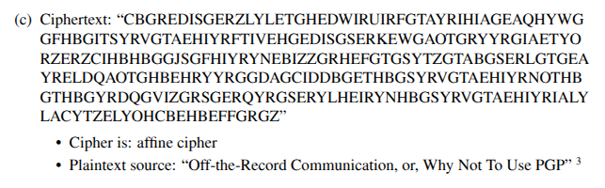
In an affine cipher, a linear function of the form (a * x + b) mod 26 Therefore, if we find the values for a and b we can find the plaintext.

The first thing I will do is analyze which are the repeated ngrams that can be found on the ciphertext.

The following main ones were found:
SYRVGTAEHIYR -> repeated 3 times.
GTAEHIYR -> repeated 3 times
EHIYR -> repeated 3 times
RYYRG -> repeated 2 times.
The first string is very noticeable as it is a string that repeats three times in a small amount of time and is a word of 12 letters which is something that is not very common in a normal text. The first word that matches the size and is common is cryptography. Therefore, we try with this word:

We generate a system of equations to compute a and b

(a * S + b) mod 26 = 2 -> (a * 18 + b) mod 26 = 2
(a * Y + b) mod 26 = 17 -> (a * 24 + b) mod 26 = 17

b = 2 - 18a

a * 24 + 2 -18 a = 17
6a = 15
→ We observe that cryptography was not the word

We need to look for more words of length 12 characters. Before that I will perform a frequency analysis to try to obtain some information about the ciphertext.

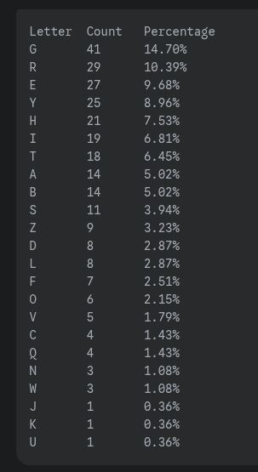 I asked Gemini to perform the counting for me.
As we observe, the most frequent letter is G. If we consider frequency analysis, this letter could match with E, T A, O which are the most frequent in English.
We are going to assume that G -> E, R -> T, E -> A, we substitute into the ciphertext to see if there is any pattern.

CBGREDISGERZLYLETGHEDWIRUIRFGTAYRIHIAGEAQHYWG
XXETAXXXEATXXXXAXEXAXXTXXTXXEXXXXXXXXEAXXXXXE
GFHBGITSYRVGTAEHIYRFTIVEHGEDISGSERKEWGAOTGRYYRGIAETYO
EXXXEXXXXTHEXXAXXTXXXXHAXEAXXXEXXTXAXEXXXETXXTEXXAXXX
RZERZCIHBHBGGJSGFHIYRYNEBIZZGRHEFGTGSYTZGTABGSERLGTGEA
TXATXXXXXXXEEXXEXXXTXXAXXXXXETXAXEXEXXXXEXXXEXATXEXEAX
YRELDQAOTGHBEHRYYRGGDAGCIDDBGETHBGSYRVGTAEHIYRNOTHB
XTAXXXXXXEXXAXTXXTEEXXEXXXXXEAXXXEXXTHEXXAXXXTXXXXX
GTHBGYRDQGVIZGRSGERQYRGSERYLHEIRYNHBGSYRVGTAEHIYRIALY
EXXXEXTXXEHXXETXEAXXXTEXAXTXXXXTXXXXEXXTHEXXAXXXTXXXX
LACYTZELYOHCBEHBEFFGRGZ
XXXXXXAXXXXXXAXXAXXETEX

We observe that RVG repeats a lot and has structure TXE, that is why I considered V -> H

Assuming that E and T are correct, we obtain the following equations

a * E + b = G -> 4 * a + b = 6
a * T + b = R -> a * 19 + b = 17 -> b = 17 - 19 a

4 * a + 17 - 19 a = 6 -> -15 a = - 11
—-------------------------------------------------------------------

As I do not find success by using frequency analysis, I decide to take advantage of the fact that there is a 12 word repeated three times in a short time, that is the ciphertext: SYRVGTAEHIYR

Before, I had checked Cryptography but it was not the correct one. I have found another word “conversation” in which in the original text, there is a series of lines in which the word conversation appears three times in a brief period of time. Exactly the same as our ciphertext. Therefore, I check with that word.

CBGREDISGERZLYLETGHEDWIRUIRFGTAYRIHIAGEAQHYWG
XXETAXXXEATXXXXAXEXAXXTXXTXXEXXXXXXXXEAXXXXXE
GFHBGITSYRVGTAEHIYRFTIVEHGEDISGSERKEWGAOTGRYYRGIAETYO
EXXXEXXCONVERSATIONXXXXHAXEAXXXEXXTXAXEXXXETXXTEXXAXXX
RZERZCIHBHBGGJSGFHIYRYNEBIZZGRHEFGTGSYTZGTABGSERLGTGEA
TXATXXXXXXXEEXXEXXXTXXAXXXXXETXAXEXEXXXXEXXXEXATXEXEAX
YRELDQAOTGHBEHRYYRGGDAGCIDDBGETHBGSYRVGTAEHIYRNOTHB
XTAXXXXXXEXXAXTXXTEEXXEXXXXXEAXXXEXCONVERSAXXXTXXXXX
GTHBGYRDQGVIZGRSGERQYRGSERYLHEIRYNHBGSYRVGTAEHIYRIALY
EXXXEXTXXEHXXETXEAXXXTEXAXTXXXXTXXXXECONVERSATIONIXXX
LACYTZELYOHCBEHBEFFGRGZ
XXXXXXAXXXXXXAXXAXXENEX

If we make the assumption of SYRVGTAEHIYR being “conversation” we obtain the following mappings

S -> C, Y-> O, R -> N, V-> V, G-> E, T-> R, A-> S, E->A, H-> T, I->I, Y->O,
R ->N

Taking these mappings into account we substitute in the beginning of the ciphertext:

CBGREDISGERZLYLETGHEDWIRUIRFGTAYRIHIAGEAQHYWG
XXENAXIXEANXXOXARETAXXINXINXERSONITISEASX
WHENALICEANDBOBARETALKINGINPERSONITISEASY <- taken from original

When we substitute we observe that there is a message that starts to be formed. Concretely, if we search in the original document for sentences that have conversation in them, we find a set of sentences that match exactly the pattern of our mapping, leading to the same message that was starting to be formed. It is impossible that an incorrect mapping leads to a set of well-formed English sentences. As a result, the mapping must be correct.

We can determine the end of the plaintext by using the mapping:

LACYTZELYOHCBEHBEFFGRGZ
OSWORDABOUTWHATHAPPENED

As a result, we have found the original plaintext.

Plaintext 3

When Alice and Bob are talking in person, it is easy to keep their conversation private. Alice can make sure no one is around, and, with the exception of a hidden tape recorder, she can be reasonably sure that no one else will hear the conversation. Further, the only evidence anyone can obtain of the conversation is Bob’s word about what happened.

Exercise 2

- In this case, it corresponds to a security issue. Lily’s company has not been able to protect their information(located in the DB) from unauthorized access. An unwanted third party has been able to break into the database and steal the company’s data. Concretely, if we consider the CIA triad, confidentiality and integrity were affected. First, by the attacker obtaining the information, confidentiality was broken. Moreover, as the DBMS has been taken down by ransomware, the information is no longer accessible by the company, hence affecting availability. It could be argued that there is a current privacy issue as if the company does not pay the required amount of money, they will not have control over who has access to their DB information as it will be shared to everyone in the network.

- For this second situation, the main issue is privacy. By installing the monitoring software, they are being deprived of their right to decide which data to share. As it is shown at the end of this scenario, the company had access to the complaints that Lily and her colleagues had discussed in the private group even though they were supposed to be private and not accessible by the company.

- For this third situation, the problem is security. Before Lily's evidence was published, there was an unauthorized third party that intercepted the communication and modified the data. In the CIA triad, this scenario is associated with integrity. The integrity of the file could not be maintained as it can be seen when Luna downloads the files and notices that the hashes do not match.

Exercise 3

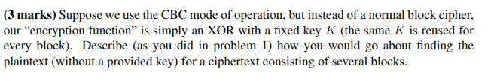
Because we are working with CBC we assume that we know the ciphertexts and the IV (Initialization Vector).
Assume that we have a CBC in which we are dealing with an initial message that leads to n blocks(n cibertexts) -> En.

This would lead to the following set of equations:
E1 = M1 XOR IV XOR K

E2 = M2 XOR E1 XOR K

E3 = M3 XOR E2 XOR K
.
.
.
En-1 = Mn XOR En-2 XOR K
En = Mn XOR En-1 XOR K

Now if we compute the XOR of each ciphertext with the previous one(previous block)
En XOR En-1 = Mn XOR En-1 XOR K XOR En-1 = Mn XOR K
En-1 XOR En-2 = Mn-1 XOR En-2 XOR K XOR En-2 = Mn-1 XOR k
.
.
.
E2 XOR E1 = M2 XOR K XOR E1 XOR E1 = M2 XOR K
E1 XOR IV = M1 XOR K
As we observe, we can obtain all the plaintext messages XOR’ed with the key K.

After this, we can notice that it leads to the same problem as the Many-Time Pad. We can now take pairs of these results and XOR them to remove the key K.

For example, M1 XOR K XOR M2 XOR K = M1 XOR M2
Now we would start making word guesses and XOR them with the previous result. For instance, we could assume the message 1 contains the word “hello”. Then we would XOR this word with M1 XOR M2. If the word is contained in the message 1, it will give the word at that same position for message 2. We would repeat that process over and over making more and more guesses.

I would focus on computing a single message because if we do obtain it, we could obtain the remaining plain text messages very swiftly. For example, if we knew most of the content of M1. We could then take M1 XOR M2 and obtain M2. Or we could even obtain the value of K directly.

Exercise 4
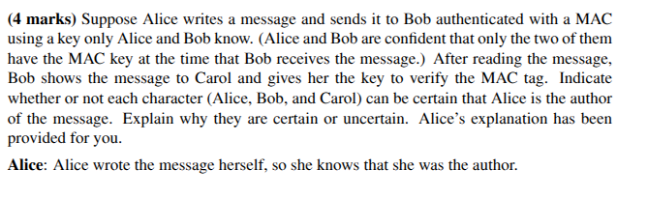
1. As it is said, Alice wrote the message herself so she knows she is the author.

2. For Bob, he would be certain as he is the one that has received the message from Alice. Assuming that the key is only possessed by Alice and Bob, he would just need to verify that the received MAC tag matches the tag that it is obtained by combining the key, MAC and the received message. As Alice is the only person apart from him that has the key, she is the only one that could have sent it.

3. However, Carol would not be able to determine who was the author of the message. With the key, the message and the MAC tag, Carol can only determine whether the message was modified or not during the transmission. For example, Bob could have written his own message and used the key with a MAC function to obtain a new tag. Then he could have given that generated tag, the message and the key to Carol. Carol would observe the same outcome, the tag matches the one of the original message. If Alice had done the same thing, it would have also led to this result. In other words, the fact that Carol can observe that the tags match does not indicate who the author was. Anyone with the secret key could have written it. As a result, there is a repudiation problem.

